The Ministry of Education
First Exam
Name: ............................................................................................................................. Class: 1 Th Grade
★ Writ the missing letters :-

….um ….rother ….ister ….ad
★ Match the word with picture :-

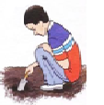
doll duck dig dad
***********************************************************************************************************
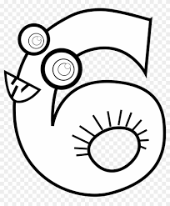

Sing sister six sun
★ Writ the missing letters :-
…ister …uck …oll …un …ing …ig …at

